EXP 08:

AIM: Write a C program to simulate a Non-Deterministic Finite Automata (NFA) for the given languagerepresenting strings that start with b and end with a

INPUT:

#include<stdio.h>

#include<stdlib.h>

#include<string.h>

#include<ctype.h>

void validate();

int s_table[3][2]={{5,1},{2,1},{2,1}},i,f;

char str[10];

int main(){

printf("enter the string :");

scanf("%s",str);

for(i=0;str[i]!='\0';i++)

if(!isalpha(str[i])){

f=1;

break;}

for(i=0;i<strlen(str);i++){

if((str[i]!='a')&&(str[i]!='b')){

f=1;

break;

}

}

if(f==1)

printf("INVALID CHARECTERS");

else

validate();

}

void validate(){

int l=strlen(str),c_state=0,f_state=2,x;

for(i=0;i<l;i++){

if(str[i]=='a')

x=0;

if(str[i]=='b')

x=1;

c_state=s_table[c_state][x];

printf("-->%d",c_state);

if(c_state==5)

exit(0);

}

if(c_state==f_state)

printf("VALID STRING");

else

printf("INVALID STRING");

}

OUTPUT:

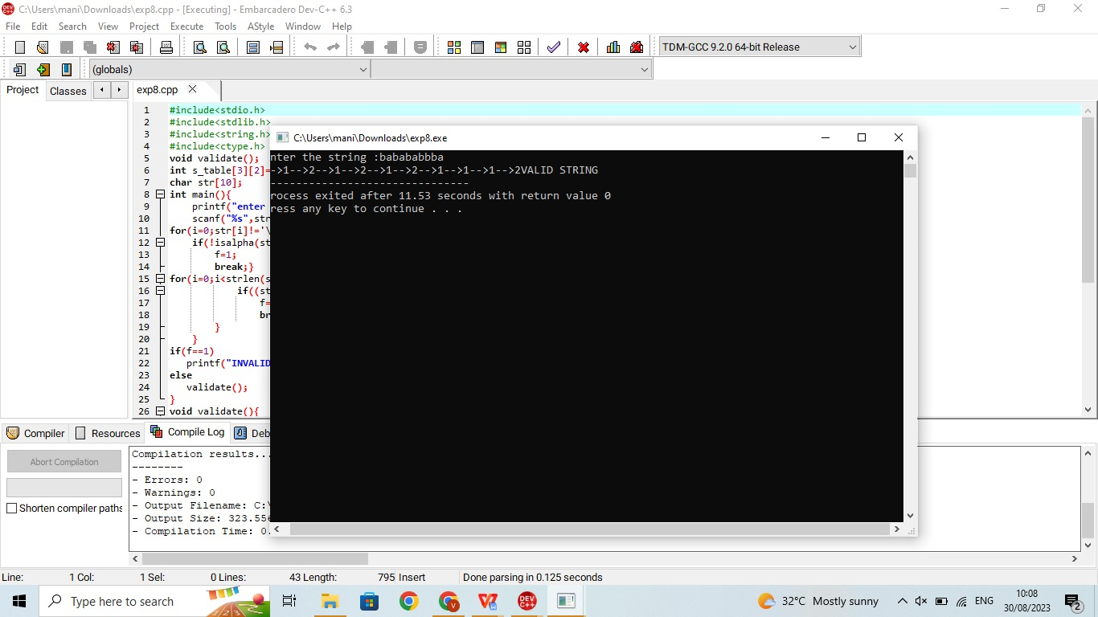

RESULT:The programm is verified successfully in dev c++